EXPERIMENT IV
BASIC APPLICATIONS OF OPERATIONAL AMPLIFIERS



Fall - 2023/2024

- 201 – Circuit Theory Lab 4 Report

Submitted By: Hızır Arda Can
Halil Mert Fıstıkçı

Student ID: 2526937
2527042

Date: 2.12.2023

OBJECTIVE: In this experiment, you learned:

1. How to set up circuit using UA741 op-amp.
2. How to measure op-amp output voltage and input voltage on circuit.
3. We observed saturation effects at the output of voltage follower op-amp circuit on the oscilloscope.

EQUIPMENT LIST:
DC Power Supply
Function/Arbitrary
Waveform Generator
Digital Oscilloscope
Op-Amp (μA741), Resistors (2x100 Ω, 4 x 1k Ω).

PRELIMINARY WORK:

1-) Open-Loop operation(without feedback)
Vin(V) | RL(Ω) | Vo(V) | I₊(mA) | Saturated(Yes/No) | Voltage limited by current? | Power Dissipation
0.002 | 3000 | 11.4 | 0.2*10⁻³ | No | No | 0.04332
0.002 | 200 | 4.7 | 0.4*10⁻³ | No | No | 0.11
2 | 200 | 4.0 | 3.2*10⁻³ | Yes | Yes | 0.08
Measurement values from lab for Figure 4.1
Vin(V) | RL(Ω) | Vo(V) | I₊(mA) | Saturated(Yes/No) | Voltage limited by current? | Power Dissipation
0.002 | 3000 | 9.9094 | 8.17*10⁻⁷ | No | No | 0.0326
0.002 | 200 | 5.101 | 8.17*10⁻⁷ | No | No | 0.130
2 | 200 | 5.121 | 1.61*10⁻⁶ | Yes | Yes | 0.131

LTspice values for Figure 4.1

- By using formula which is Power= Voltage² / Resistance we find the total dissipation of the circuit.
- Simulated and measured values are approximately the same; the difference between the values is due to op-amp high having resistance at the input.

2-)
A-)
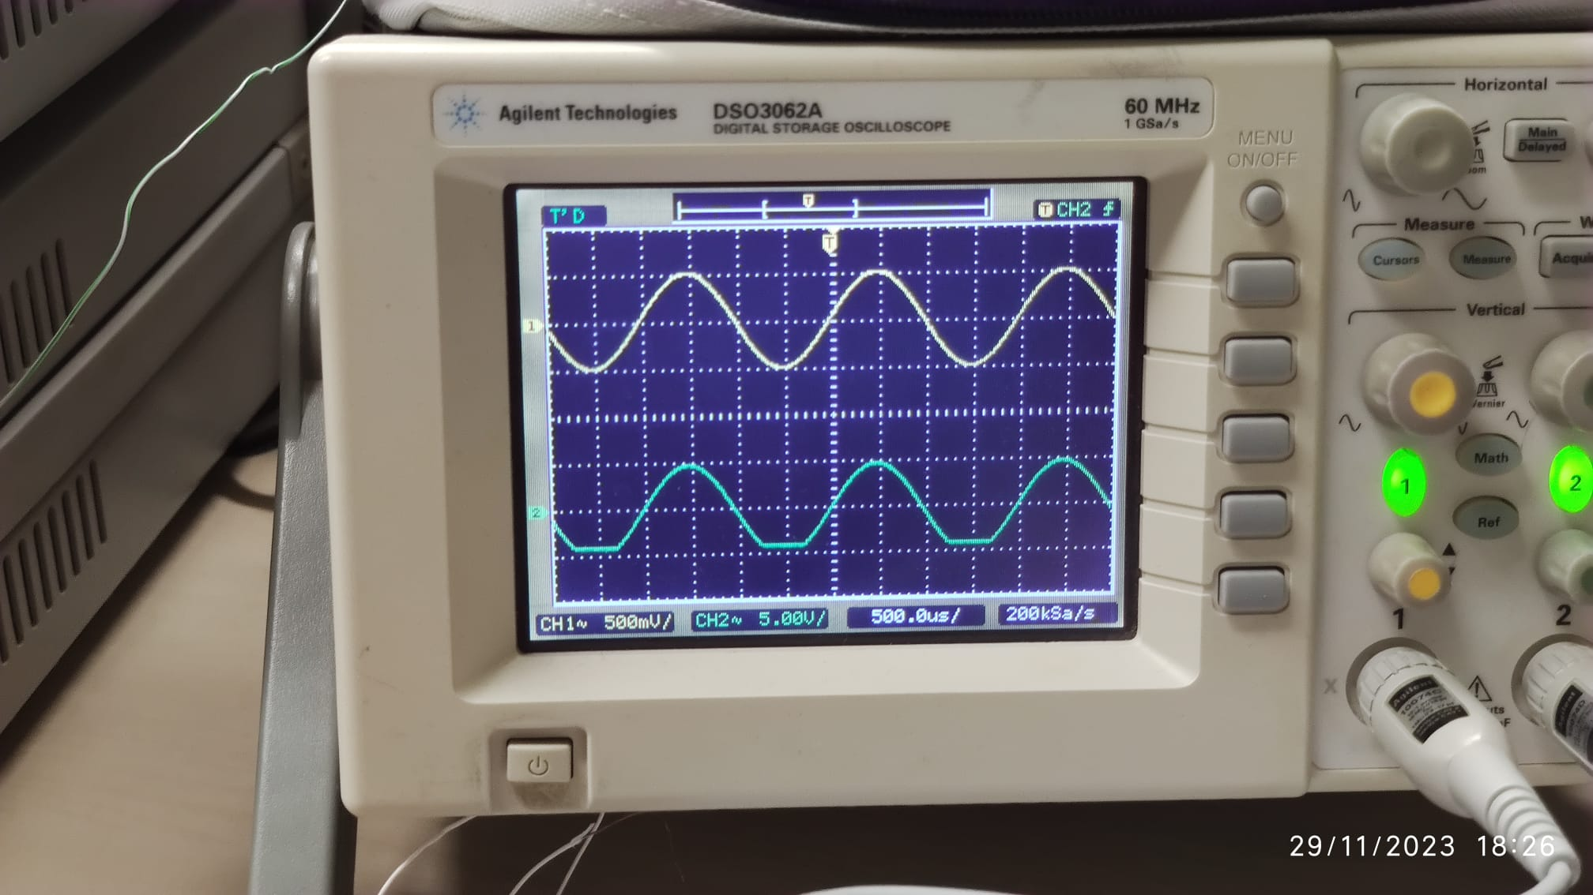
We can monitorize graphs are identical when Vpp around 6. That is equal what we calculated in prework. Vin=Vout.

B-)
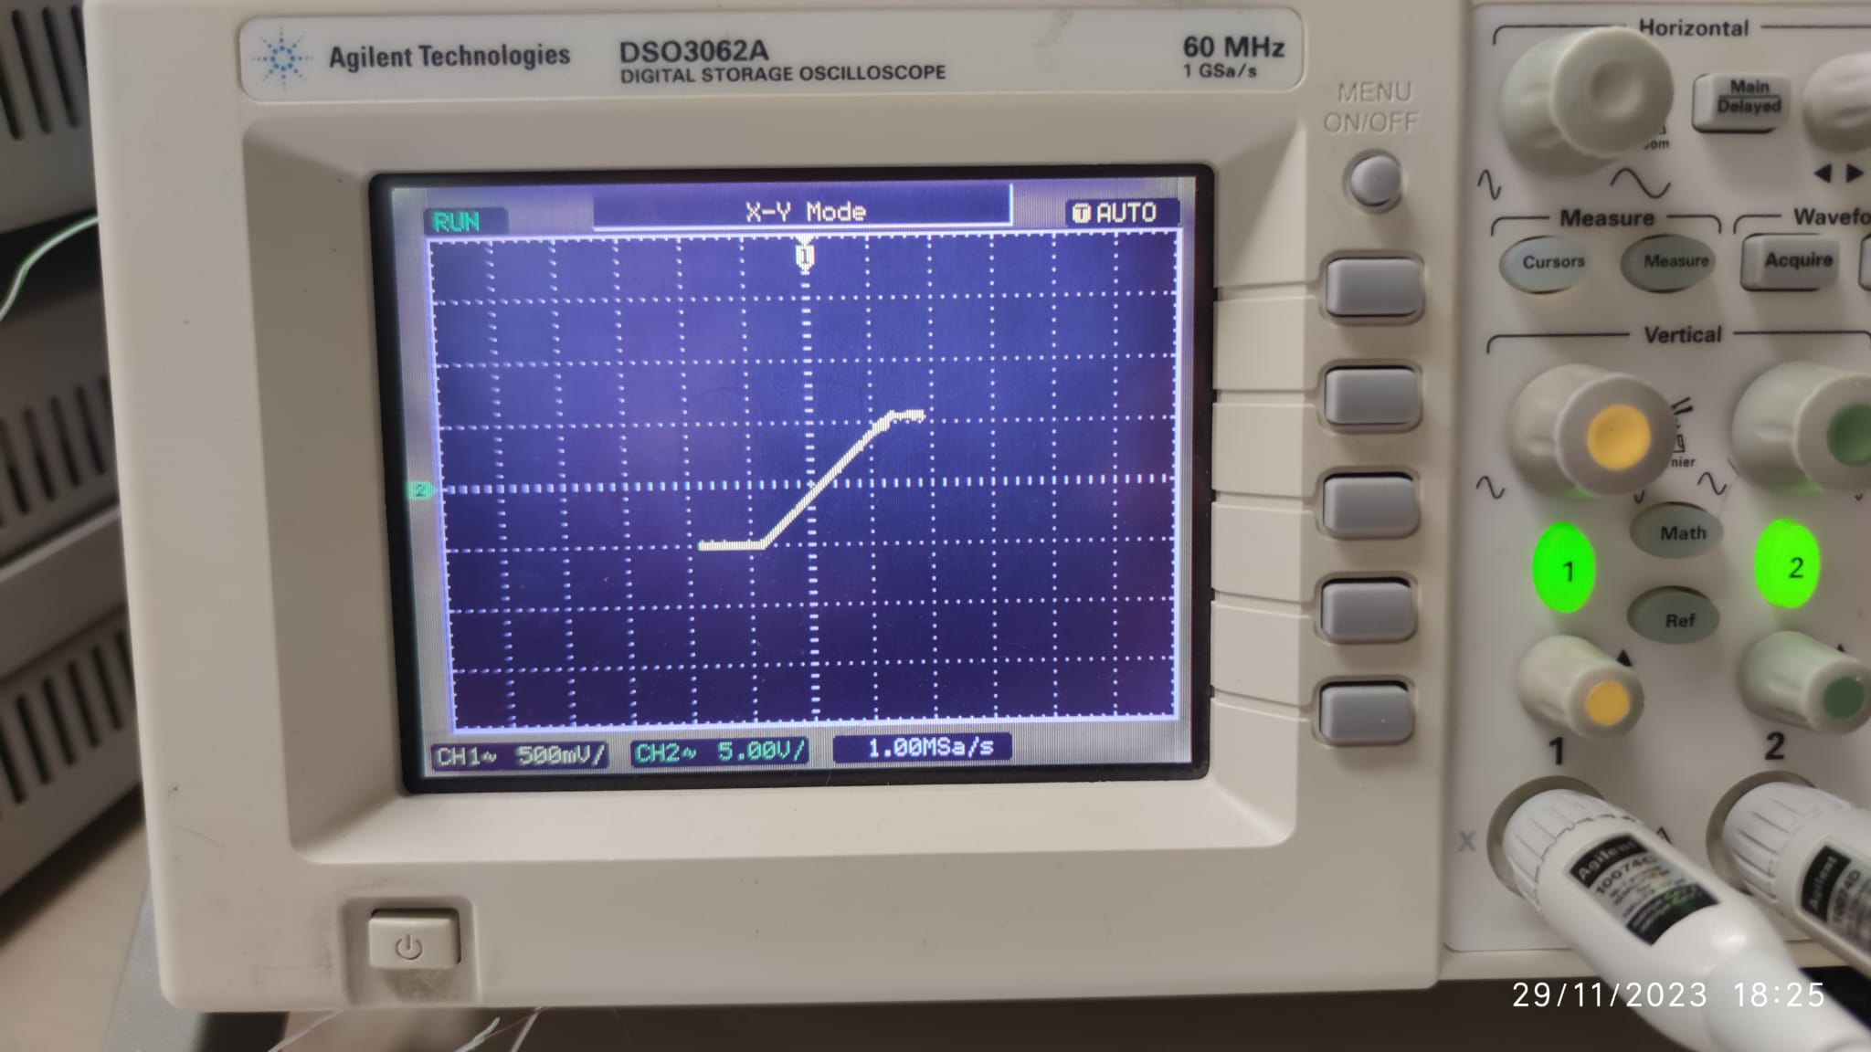
There is a linear relation with Vin and Vout, so that graph looks like y=x graph.

C-)
Measured | Calculated | Error(%)
0.95 volts | 1 volts | 5
7.52*10^-5 watts | 8.3*10^-5 watts | 10
7.52*10^-5 watts | 8.3*10^-5 joules | 10

3-) 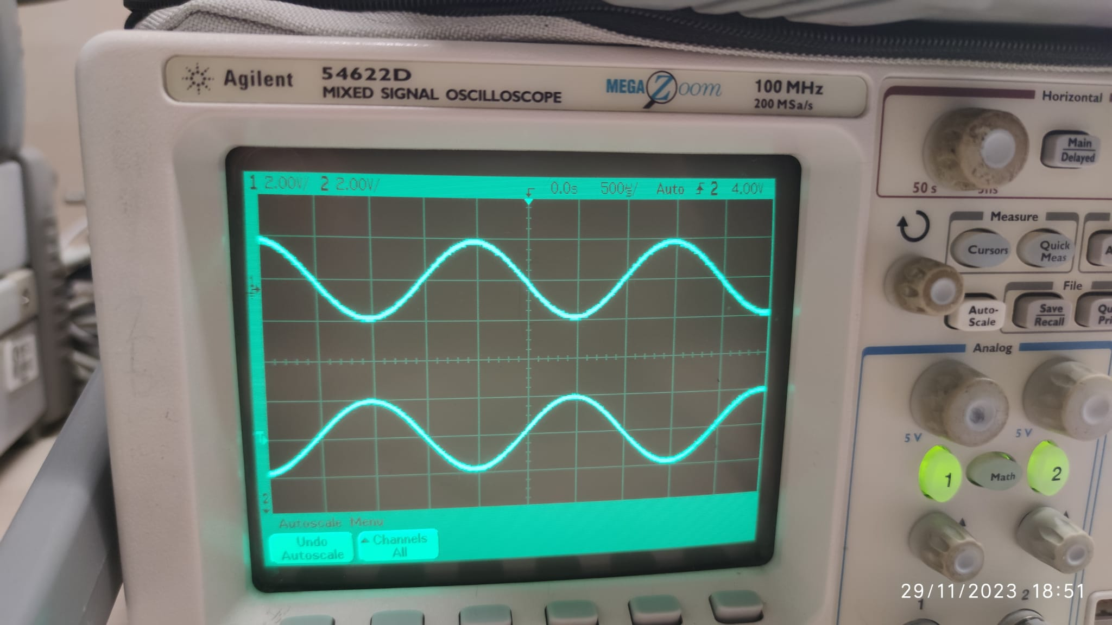

The result we measured for figure 4.5 using oscilloscope is very similar to the LTspice result
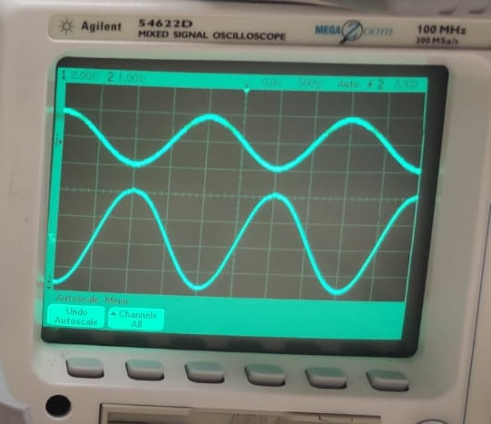

After slowly reduced.

When we reduce Vb to 1 volt voltage, we easily see that the output increases.

Conclusion

We learned how to build a circuit using an operational amplifier.

In the first part of the experiment, we observed the change of v0 voltage and current by using different voltage and resistance values.

In the other part, we examined the graphics using a function generator and an oscilloscope, and then compared the values ​​with the direct current values.

In the last part, we performed the operations in the previous part for the last circuit.

As a result, we tested the in-circuit behavior of operational amplifiers using different sources and compared their graphics.

